**Project management with GitHub**

**Introduction:**

We will use GitHub as a tool to plan and track requirements (*Projects menu*). We will also store project code (*Code menu*) and documentation (*Wiki menu*).



The code should be accompanied by explicit descriptions of the changes made by each team member. In addition, a README should be included with instructions on how to execute the project, for example:

All requirements shall be recorded in the Backlog and their status shall be updated according to progress. Each requirement must have its description, the person responsible for its fulfillment and the iteration in which it will be developed, for example:

The Wiki should be organized by sections: deliverables, meetings (weekly and retrospective) and class activities. Each deliverable, meeting or activity should be recorded on a Wiki sheet. Each meeting should be identified with its date of completion, for example:

**Project creation:**

1. Each team member must create an account on GitHub.

Go to the website <https://github.com/>, then click on the **Sign up** button.

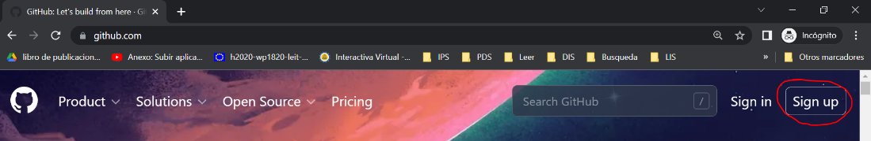

Enter the EAFIT email address, then press the **Continue** button.

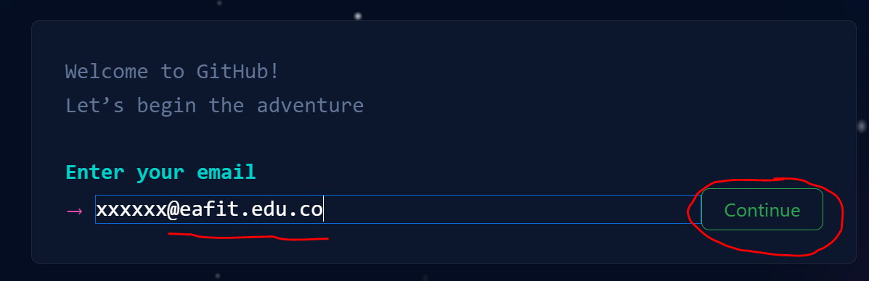

Enter a password, then press the **Continue** button.

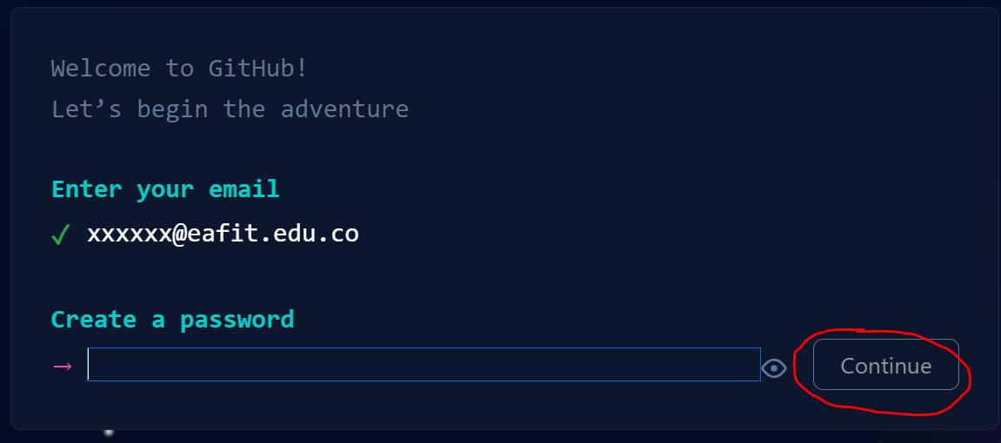

Follow the account verification instructions. Select the **Free** ($0) plan.

**Repository creation:**

1. One of the team members must create a repository.

Go to the website <https://github.com/new>.

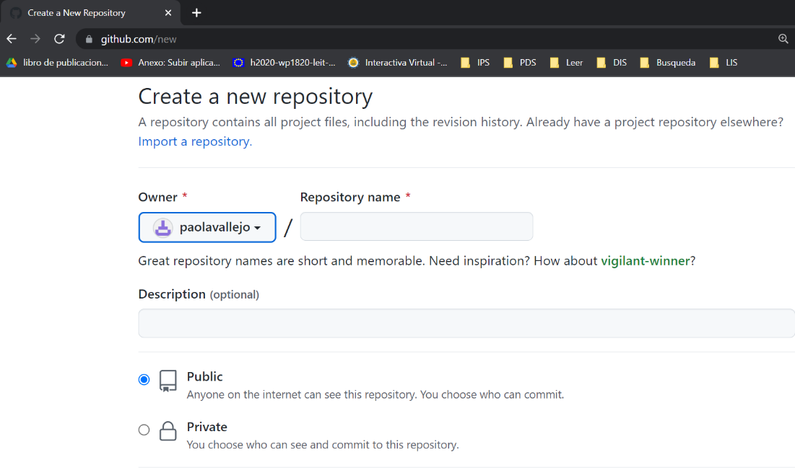

Assign a name to the repository (use project or product name), add a description, indicate that it is **Public**, then press the **Create repository** button.

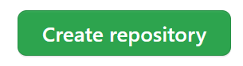

1. The team member who created the repository must invite the other team members.

Enter the **Settings** option.

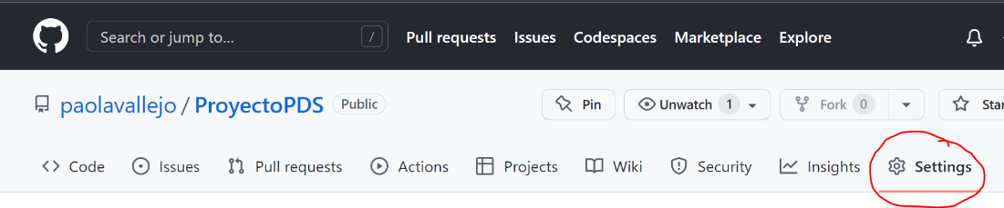

Select the **Collaborators** option.

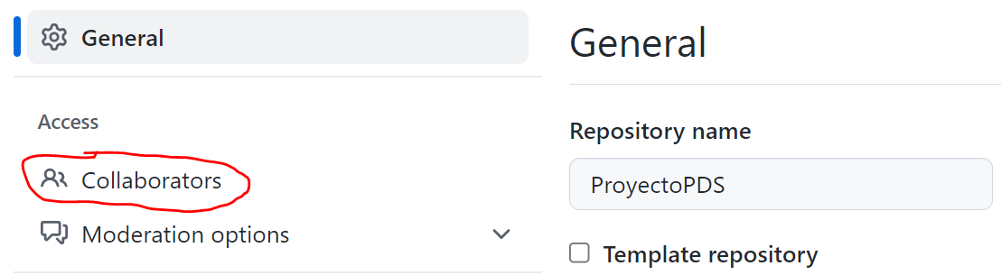

Select the **Add people** option.

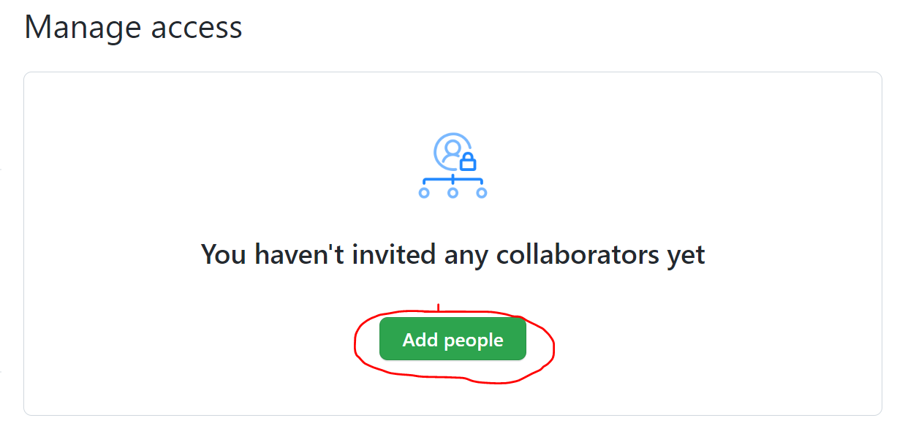

Search for a team member by username, full name or email. Then select the option **Select a collaborator above**. Finally, **Add X** (where X is the name of the collaborator to add) **to this repository**. Do this for each collaborator you want to add, including your professor.

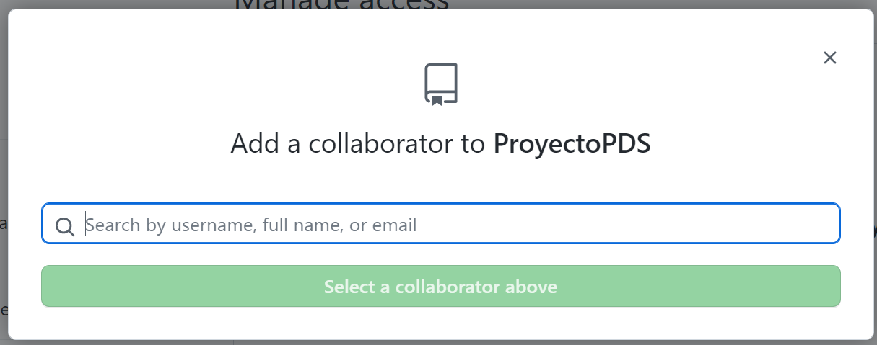

The invited collaborator will receive an e-mail with the instructions for joining the project.

**Backlog creation:**

1. One of the team members creates a project.

Select the **Projects** option. Then, select the **New project** option.

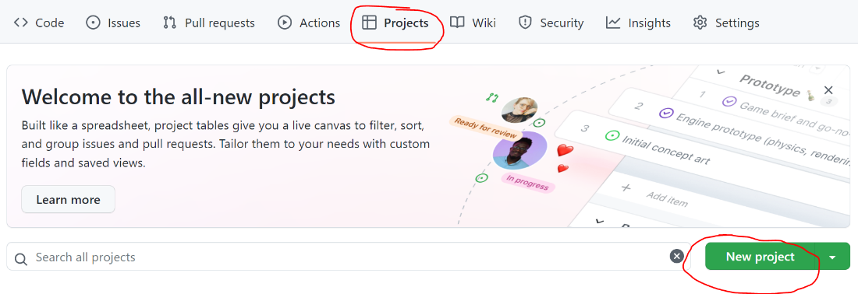

Select the **Board** option. Then, change the name of the project to **Backlog**. Finally, select the **Create** option.

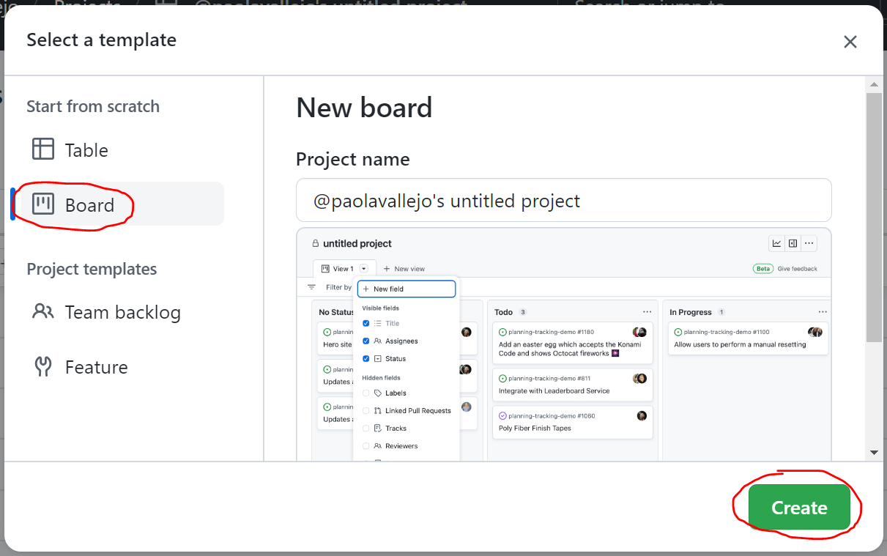

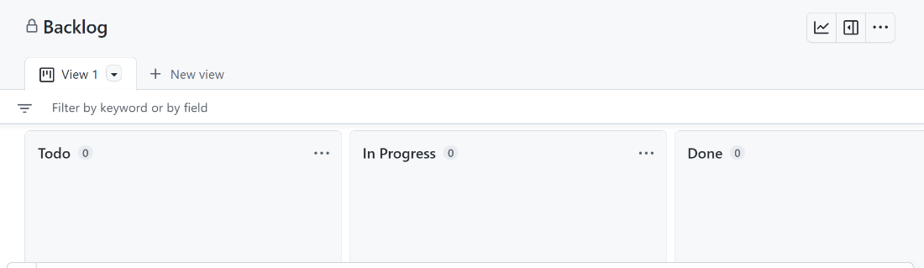

1. Team members add the tasks (requirements) that they will develop during the semester.

Add the name of the task and press the **Enter** key. This name must contain the unique identifier of the requirement and be concise to quickly recognize what the requirement is about.

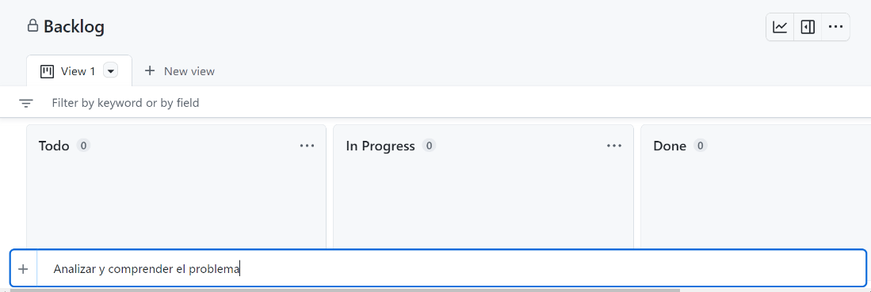

The task Will appear as **Draft** (**No Status**).

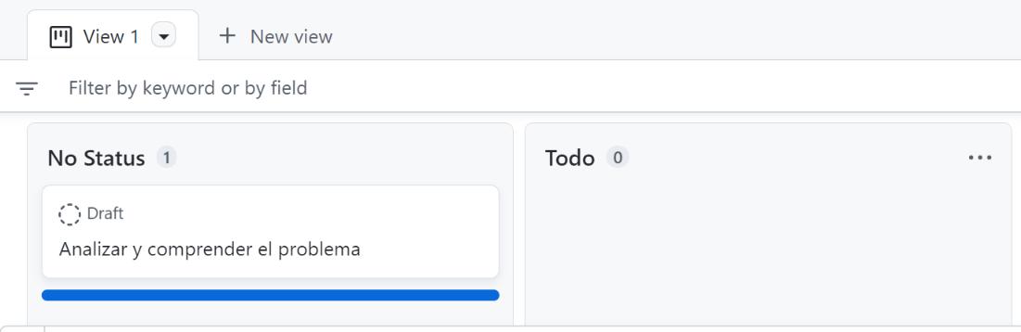

Press the **...** to the right of Draft. Then select the **Convert to issue** option.

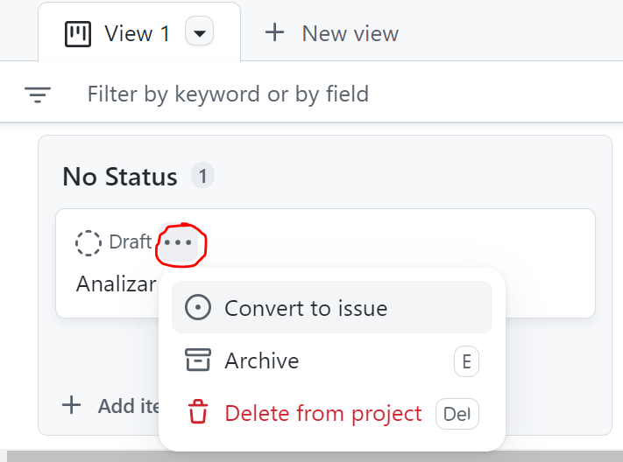

Select the name of the repository you created in step “2. One of the team members must create a repository”.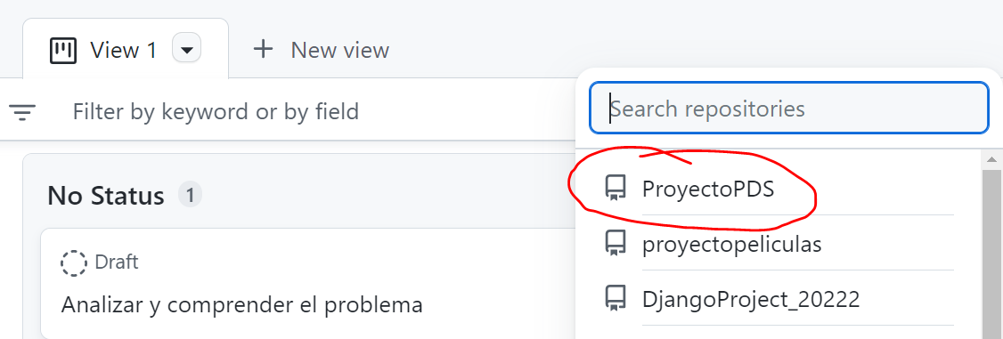

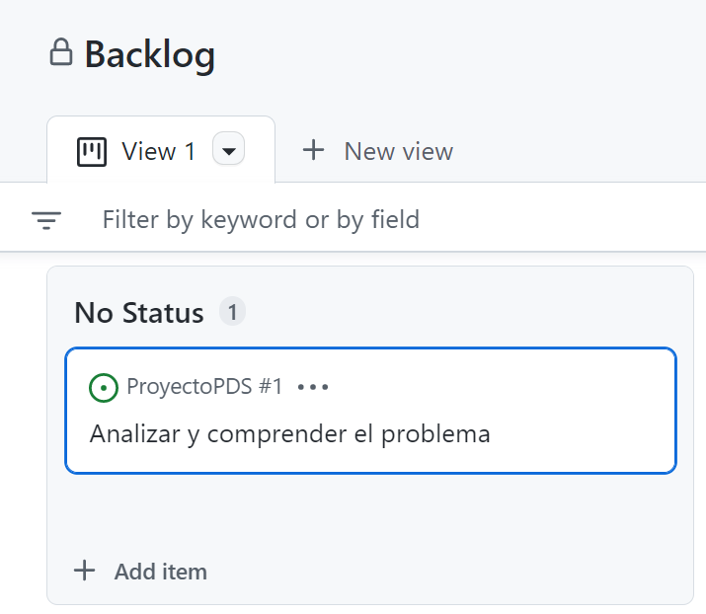

Drag the task to the **Todo** column.

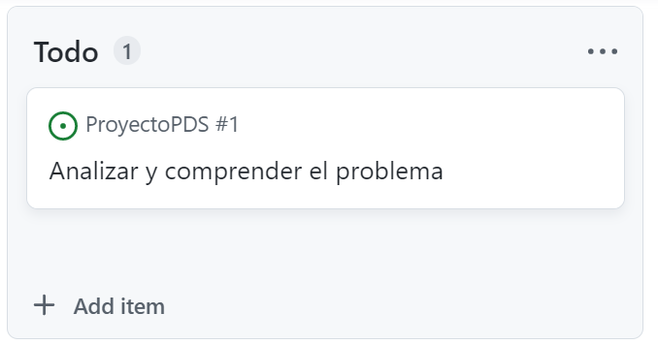

Select the task name to see more details.

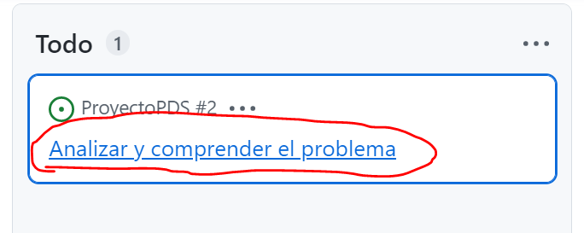

Add a description to the task and select the name of the member responsible for working on the task. The description should follow the format seen in the requirements specification template.

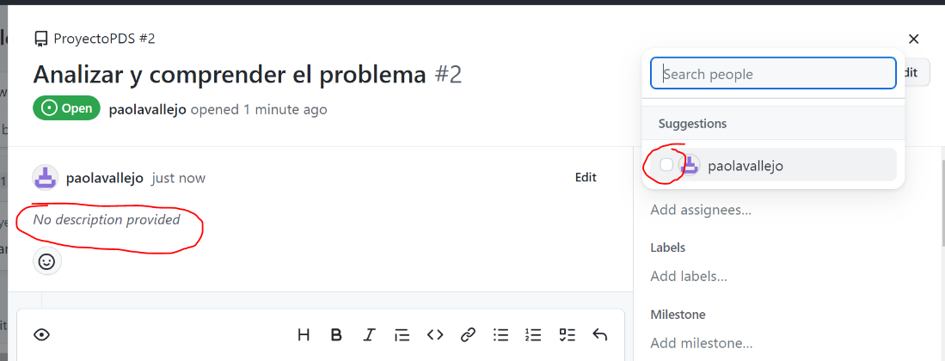

You should follow the same process for all project tasks.

**Wiki creation:**

1. Team members create and edit the Wiki.

Go to the **Wiki** menu. Then, select the **Create the first page option**.

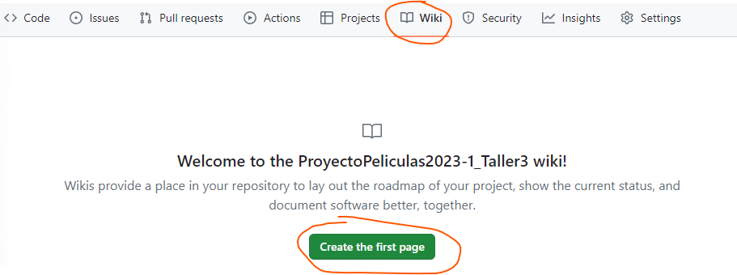

**Edit** and **save** the page.

Visualize the page and edit it at any time.

The following link contains a more detailed tutorial for adding or editing a project wiki: <https://github.com/jdmartinev/ProyectoPI_wiki>